BLIND VETERAN PIONEERS A NEW MEMORIAL IN NORMANDY
Blind Veteran, Chris Lowe, has attended the unveiling of a new regimental memorial in Normandy, which he has helped to organise over the past two years. The installation of the new memorial on the 80th anniversary of the Normandy Campaign commemorates the action of 176 Brigade in the fierce Battle of the Orne Bridgehead at Grimbosq.
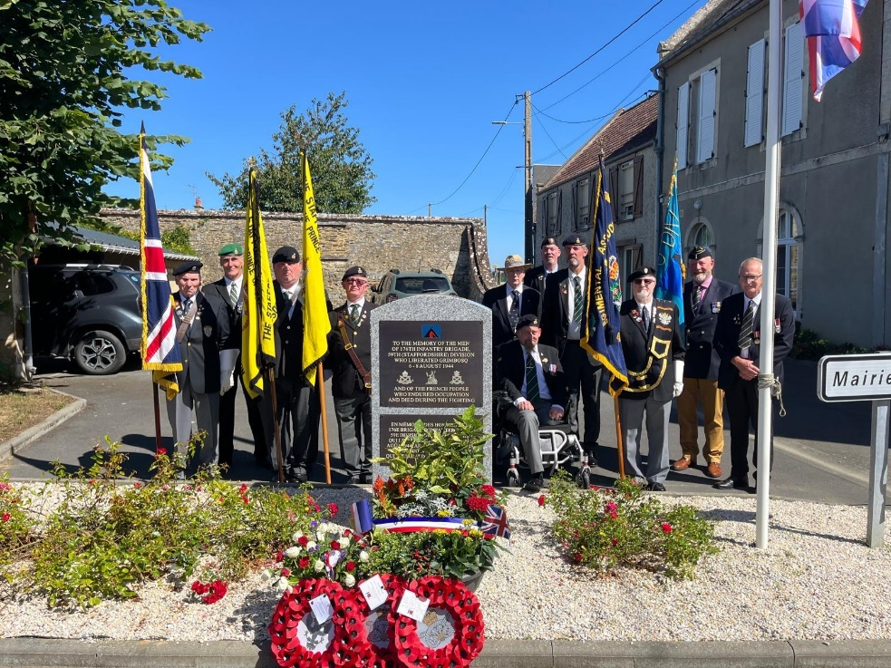
British and French veterans beside the new memorial in the Grimbosq village square.
After his National Service with 1st Battalion, The North Staffordshire (Prince of Wales’s) Regiment, Chris served for twelve years with the territorials in the 6th Battalion. It was this battalion, along with battalions from The South Staffordshire Regiment and supporting units, that had performed heroically in the push to cross the River Orne, south of Caen in early August 1944 and establish what became known as the Brieux bridgehead. As part of 59th (Staffordshire) Infantry Division, 176 Brigade held the bridgehead and ultimately triumphed over the fanatical 12th SS Panzer Division (Hitlerjugend). Chris subsequently served with men from the battalion who had fought with such bravery, crossing the Orne and holding the bridgehead for three days.
‘They never ever talked about their experiences,’ said Chris. ‘It was only on a visit to Normandy with my military historian friend, Phil Joslin, that we uncovered the full story. We were astonished by the doggedness and heroism of both the soldiers and the civilians in the area. It was a story that had to be told.’
The inhabitants of the small village of Grimbosq have never forgotten the sacrifice of the Staffords and the units that supported them in securing their liberation.

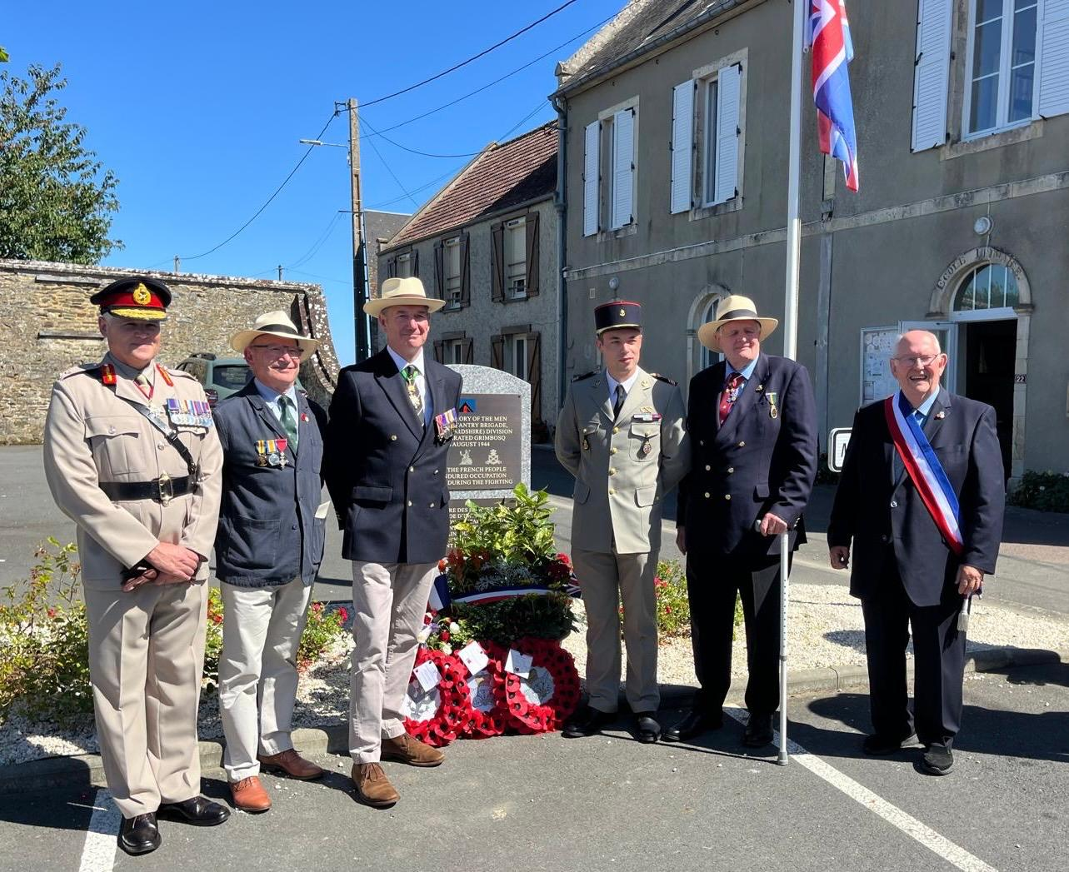
Chris Lowe wth (L to R) Lt. General Sir Ian Cave, Phil Joslin (author), Brigadier Jim Tanner, aservimg soldier of the French arm, Chris, Jean-Paul Lemaire(Deputy Maoyor of Grimbosq and co-ordinator of the ceremony)y,
On the morning of 10th August, Lieutenant-General Sir Ian Cave, Colonel of the Mercian Regiment, along with the mayor of Grimbosq, unveiled the new memorial in the Grimbosq village square. The wreaths laid by General Sir Ian and the mayor of Grimbosq, Gilles Bunel, were handed to them by pupils of the local primary school. The touching involvement of young people was enhanced by heartfelt tributes by two youngsters who spoke of the importance of keeping alive the story of the sacrifices made by the soldiers and villagers. The wording on the plaque poignantly links remembrance of both liberators and villagers. At the end of the ceremony the Last Post was sounded, flags were lowered by both French and British veterans, and both national anthems were played.
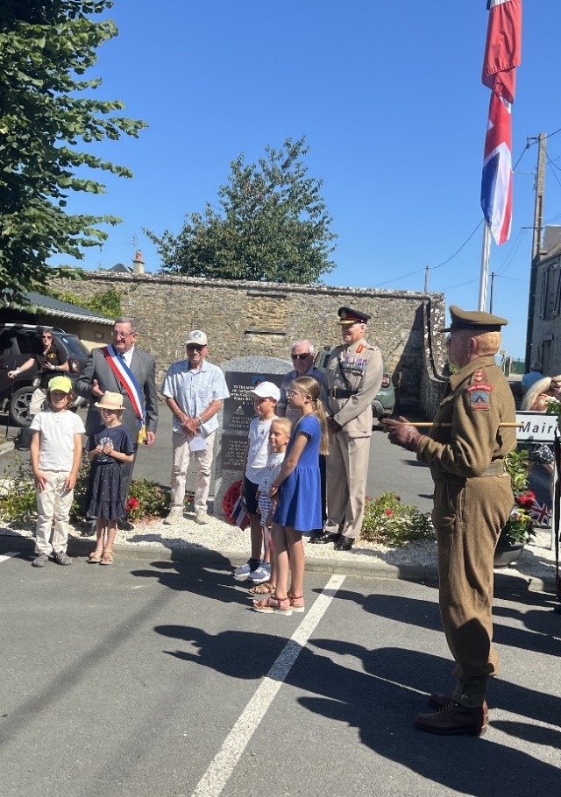
Village children who helped General Cave to lay his wreath, along with two men in their nineies who witnessed the occupation and liberation of Grimbosq when they were 1 in their teens. On the right is the leader of the local re-enactment group, Friends of the 59th, wearing 1940’s battledress.
Two of those present from the village, now in their nineties, were just boys at the time of the mayhem and slaughter that went on all around them. Their village was largely destroyed, but finally they were liberated. Chris commented, ‘They bear no ill-feeling; in fact, they have nothing but love and respect for the territorial soldiers who came to free them.’
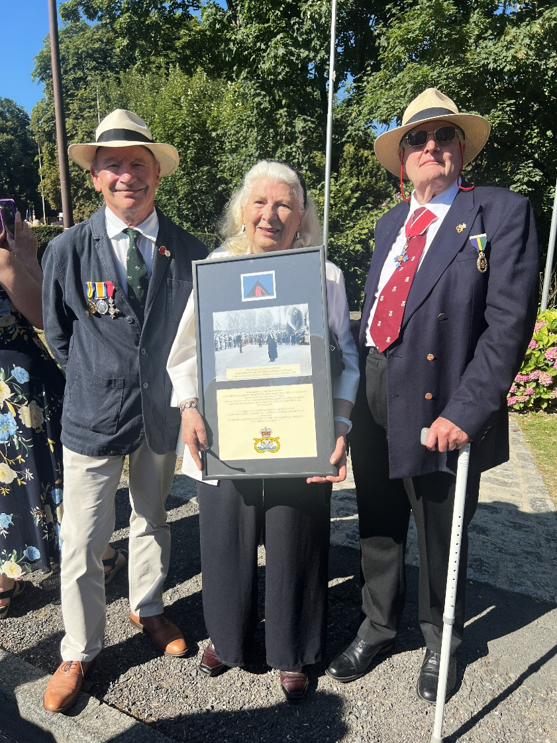
Chris and author Phil Joslin with 96 year old Micheline Guillerm, founder of the ‘Memory Space’ at Yhury-Harcourt. She is holding a framed photograph of the original 1953 unveiling of the Thury-Harcourt memorial to the 58th (Staffordshire) Infantry Division
In the afternoon, villagers, visitors and the Friends of the 59th (Staffordshire) Division paid their respects at the riverside memorial to a British soldier, Ernie Blincow, a Royal Artillery gunner from Staffordshire, who after the war spent some 60 years fostering a lasting relationship with the area he had fought over. Finally, the British visitors and French hosts stood on the bridge over the Orne, Le Pont de Brie, and cast flowers into the water. This bridge was at the centre of the battle, and Brieux Bridgehead became a battle honour of the North Staffordshire Regiment.
‘There were not many dry eyes at that moment’. Chris noted.

The damaged bridge over the Orne at the height of the battle on 7-8 August 1944.

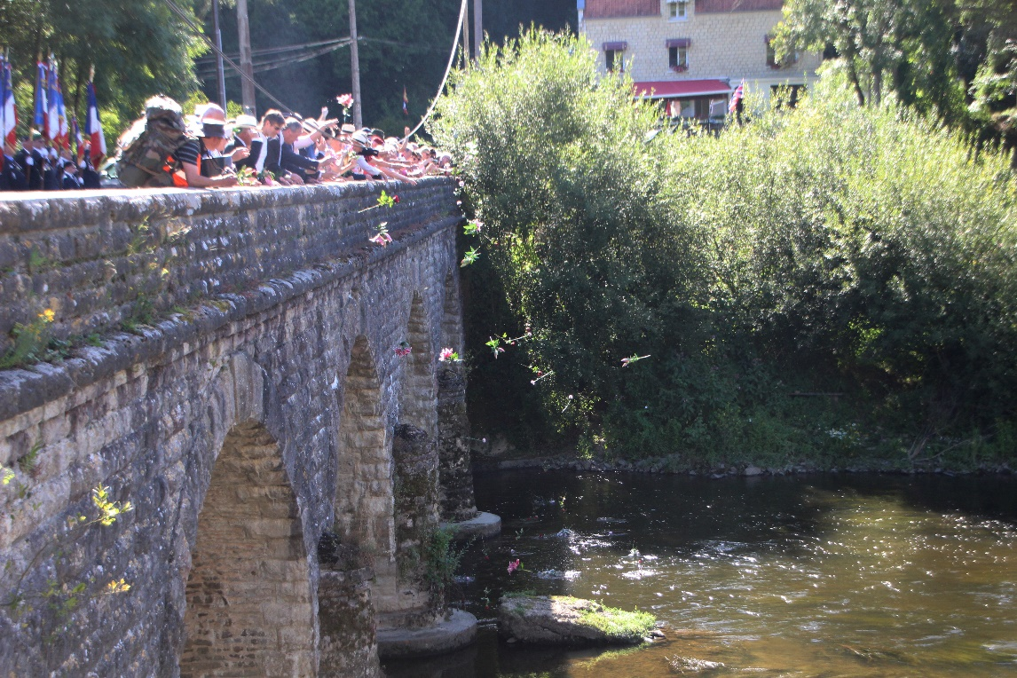
Tge same bridge in August 2024. Veterans, villagers and tourists are thoeing flowers into the river in memory of the sacrifices made at this spot 80 years ago.; During the battle the cellar of the restaurant at the side of the brige was used by North and South Staffords as a refuge from the shelling.
The following day in nearby Thury-Harcourt more wreaths were laid, this time at the memorial to the 59th Infantry Division. Brigadier Jim Tanner, former Colonel of the Staffordshire Regiment, laid the regimental wreath and the mayor of Thury-Harcourt, Philippe Lagalle, veterans and local people added theirs. This was followed by parades and re-enactments by the local Friends of the 59th Division dressed in 1940’s battle-dress and carrying authentic weapons and equipment.
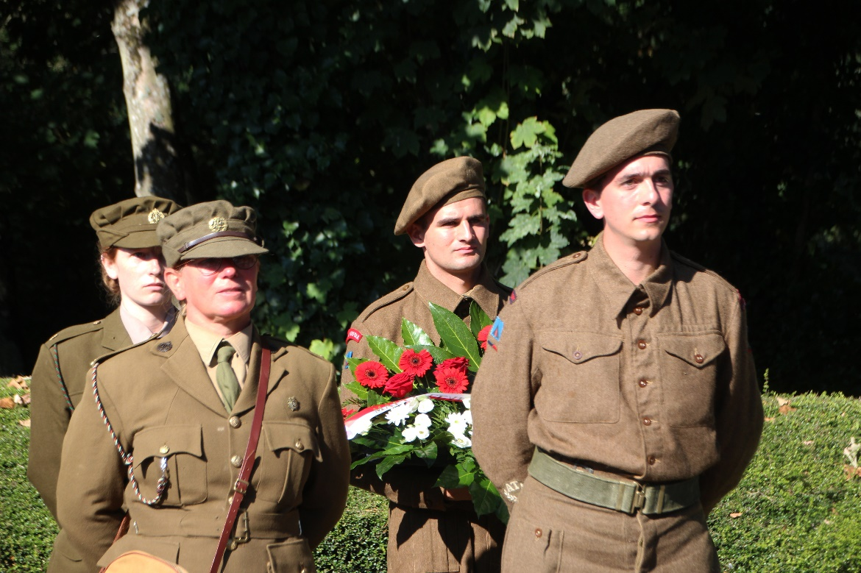
Men and women of the very active ‘Friends of the 59th Division in 1944 battledress laying a wreath at the Thury-Harcourt memorial to the 50th Division.
The visitors from the Staffordshire Regimental Association attended a mass to the fallen, then took lunch with the mayor and local dignitaries. This was followed by further re-enactments of the liberation, a 1940’s dance and, finally, a firework display.
Throughout the day, the town’s ‘Espace Memoire’ (Memory Space) to the 59th Division was open, displaying hundreds of photographs, letters and memorabilia, given by the soldiers and their families over 80 years of repeated visits. The special events over the weekend were a moving expression of the affection for the British liberators of their town - best summed up by notices in the Town Hall and in many shop windows – Welcome to our Liberators, Thank You.
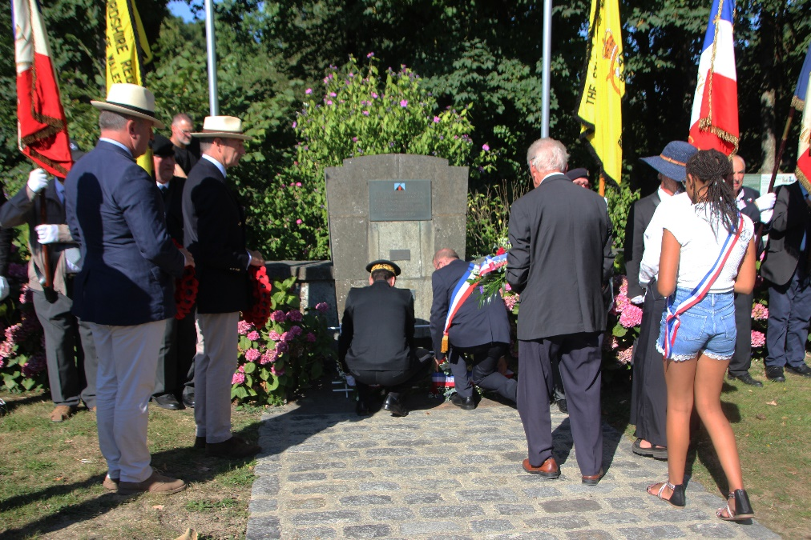
Wreaths being laid b at Thury-Harcourt y the Prefect of the Department of Calvados with the Chief sof Police and Fire Servicse along with Brigadier Jim Tanner and local people., flanked by French and British standard bearers.
The Staffordshire Regimental Association’s visit ended with a short ceremony at the British military cemetery at Fontenay Le Pesnel. Here, many of the 241 soldiers who died in these Orne battles now rest in peace. A wreath was laid on the memorial to all those who were killed. Another was laid on the grave of a South Stafford soldier, while Chris laid a wreath on the grave of a North Stafford soldier.
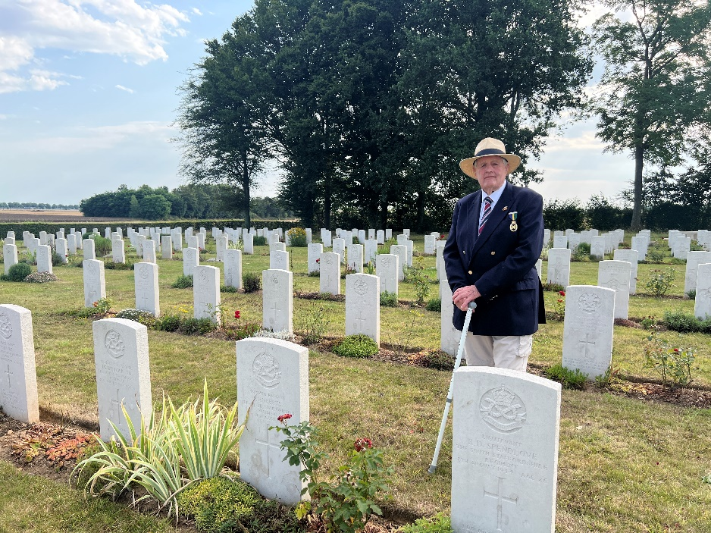
Chris at the graveside of a North Staffordshire Regiment soldier from Longton, Stoke-on-Trent, in the Commonwealth cemetery at Fontenay le Pesnel in Normandy.
‘All these ceremonies and acts of remembrance,’ said Chris, ‘gave real meaning to the simple, oft-repeated message, ‘We shall remember them’
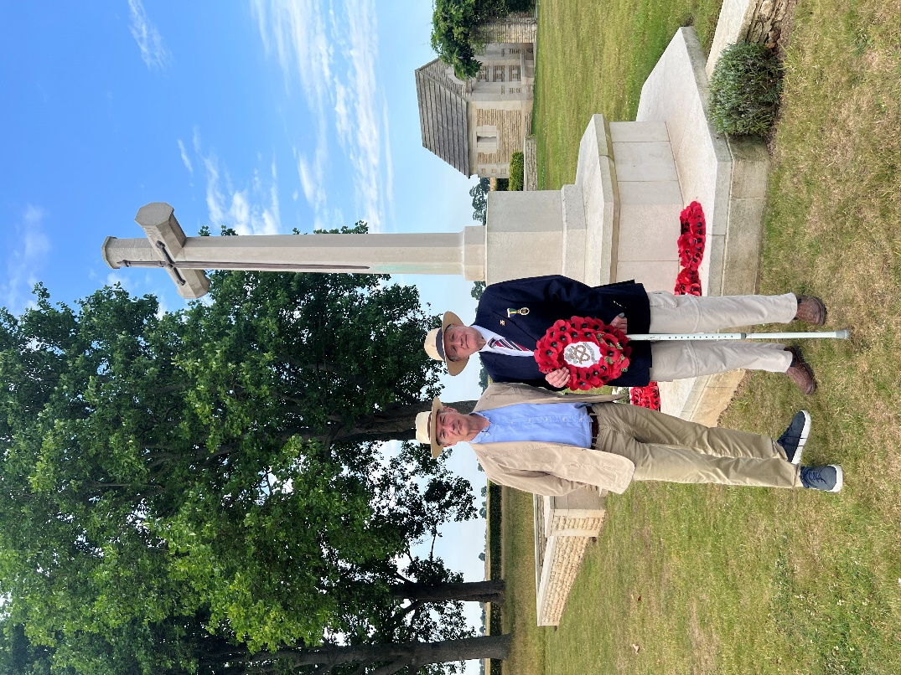
Chris with Brigadier Jim Tanner, former Colonel of the Staffordshire Regiment, at the after the laying of a wreath in memory of all the soldiers of the North and South Staffordshire Regiments, who gave their ives in Normandy 1944.
A new book telling the detailed story of the bloody battles across the hills of Normandy and over the River Orne, leading to the final rout of the German army at Falaise, is now out. Author Phil Joslin’s book The Hills of Hell captures the excitement of the fierce fighting by the 59th Division, from the Normandy beaches, through the bocage around Caen, to the formidable barrier of the River Orne and the surrounding hills. It contains many photos that have never been published since they were taken during the battles. So fierce was the fighting that, after the war, detailed French maps of the area call the hill above Thury-Harcourt La Colline d’Enfer, the Hill of Hell. To the Staffordshire soldiers at the time, all the hills and ridges were ‘hills of Hell’. Today, thankfully, they are havens of peace and tranquillity. The book can be ordered directly from the Staffordshire Regimental Museum at Lichfield by phone or email.
If you wish to pay your own respects to these gallant territorial soldiers, visit the war memorial in Stafford (opposite the railway station) or the commemorative tree, donated by the people of Thury-Harcourt, at the National Memorial Arboretum at Alrewas. Further information relating to the Normandy Campaign can be found at the Staffordshire Regimental Museum.
Chris Lowe
August 2024

